CSC 555 Mining Big Data
Assignment 6

Nikhil Bhalala
Due Sunday, 6/5
Suggested Reading: Hadoop: The Definitive Guide Ch19; Mining of Massive Datasets: Ch9

  - Solve 9.3.1-a (normalize the ratings based on a threshold), 9.3.1-e
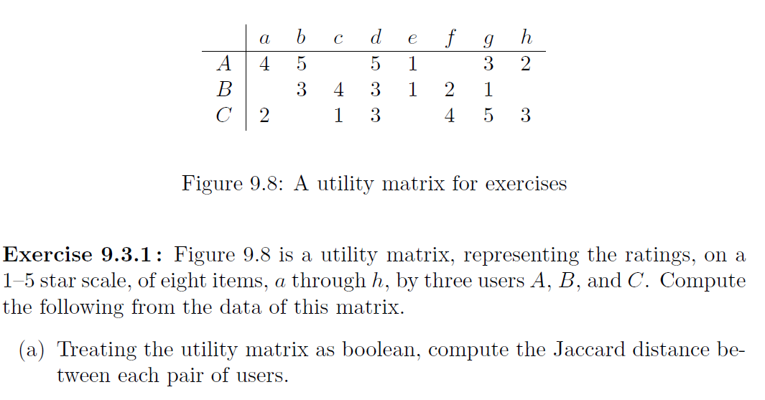

(a)
 | a | b | c | d | e | f | g | h
A | 1 | 1 |  | 1 |  |  | 1
B |  | 1 | 1 | 1
C |  |  |  | 1 |  | 1 | 1 | 1

A & B: Distance = 3/5 (0.6)
A & C: Distance = 6/7 (0.86)
B & C: Distance = 5/6 (0.83)

 | a | b | c | d | e | f | g | h | Avg
A | 4 | 5 |  | 5 | 1 |  | 3 | 2 | 3.33
B |  | 3 | 4 | 3 | 1 | 2 | 1 |  | 2.33
C | 2 |  | 1 | 3 |  | 4 | 5 | 3 | 3

Average is substract

 | a | b | c | d | e | f | g | h | Avg
A | 0.67 | 1.67 |  | 1.67 | -2.33 |  | -0.33 | -0.67 | 3.33
B |  | 0.67 | 1.67 | 0.67 | -1.33 | -0.33 | -1.33 |  | 2.33
C | -1 |  | -2 | 0 |  | 1 | 2 | 0 | 3

  - Describe a strategy that is used to make a utility matrix less sparse
- By grouping people or objects based on a distance metric, one can reduce the sparsity of a utility matrix. The values assigned, for instance, would be the average ratings for each user for the columns in each cluster. Items might then be grouped into a smaller subset.

  - Describe at least one mechanism that ensures that data is not lost in Spark when a failure occurs.
- If appropriate replication is specified for HDFS, Spark reads data from HDFS into memory for processing but otherwise stores it in HDFS, preventing data loss after failure. In this way, Spark makes sure that data is not lost in the event of a failure.

  - From a resource (i.e., disk, memory, CPU) managing perspective, which Hadoop nodes should be chosen to run Spark tasks?
- Spark should be executed on master Hadoop nodes from a resource management standpoint.

  - Implement (in python only, without actual Storm) a solution that would compute streaming queries average for a specified window. For example, to compute a 4-value windowed average that moves 2 tuples at a time, you can use the following line (make sure that your code supports other sizes as well).
You are not allowed to first read the entire input before producing output, because the input stream is infinite. Instead, you should compute and print the output as the data arrives.

cat mydata | python storm.py 4 2

This can be tested in your own environment, without Linux, using the following code:
fd = open(‘mydata’, ‘r’)
sys.stdin = fd
for line in sys.stdin:
# Your code goes here.

Assuming that mydata file contains (one value per line, no error checking is necessary)
5
3
5
11
6
4
5
3
7

Your command above should output the following three averages (representing an average of (5,3,5,11), (5,11,6,4), (6,4,5,3)):

6
6. 5
4.5

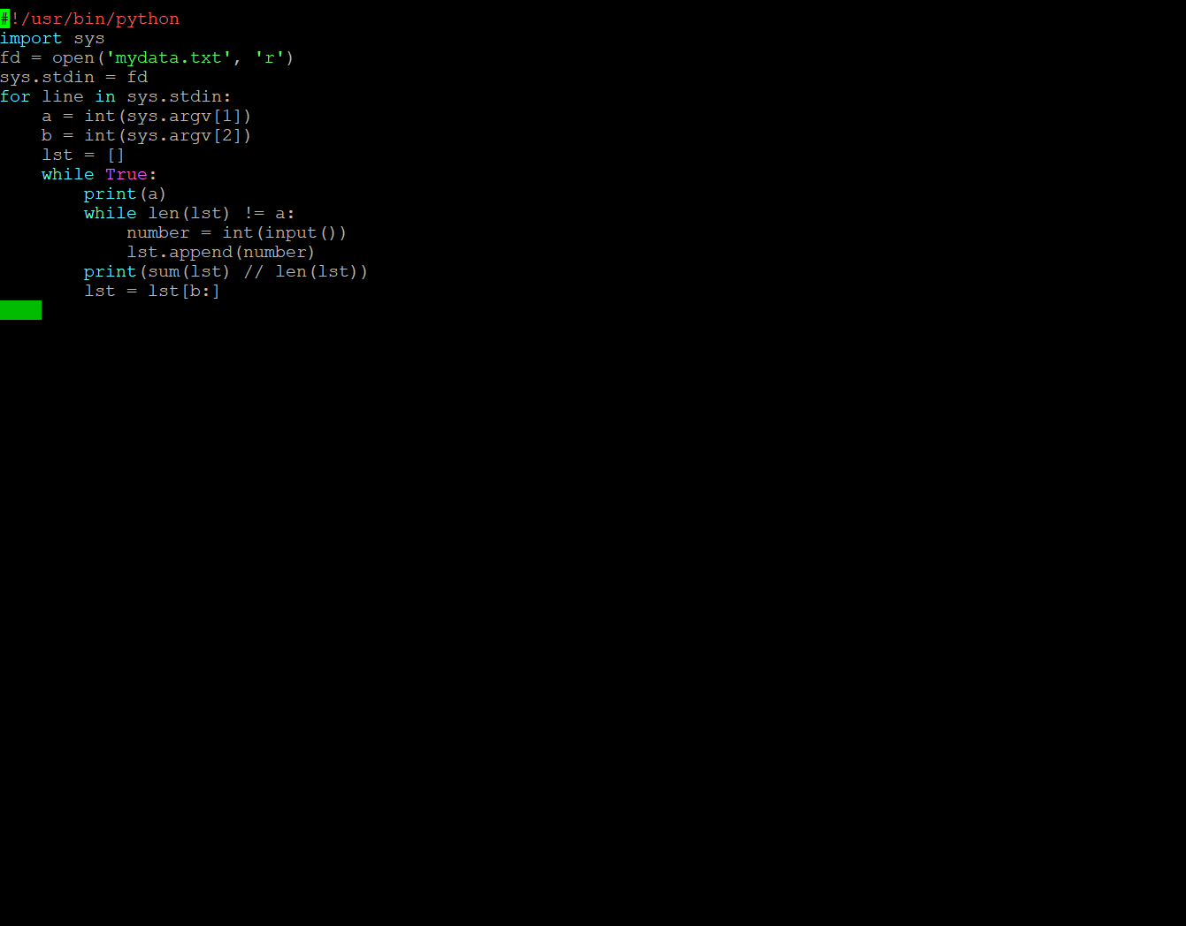

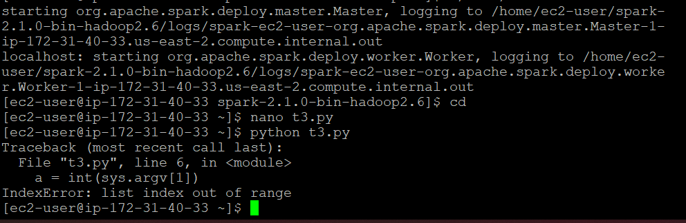

Error is showing me

- Download and setup Mahout. You should use your single-machine cluster for this assignment.

  - Run KMeans clustering using Mahout:
cd
(download mahout zip package)
wget http://cdmgcsarprd01.dpu.depaul.edu/CSC555/apache-mahout-distribution-0.11.2.zip
(Unzip the file)
unzip apache-mahout-distribution-0.11.2.zip

set the environment variables (as always, you can put these commands in ~/.bashrc to automatically set these variables, and run one-time source ~/.bashrc to refresh now)
export MAHOUT_HOME=/home/ec2-user/apache-mahout-distribution-0.11.2
export PATH=/home/ec2-user/apache-mahout-distribution-0.11.2/bin:$PATH
be absolutely sure you set Hadoop home variable (if you haven’t yet):

Create a new numeric file with 370,000 rows and 7 columns, separated by space – you can generate numeric data as you prefer, but submit the code/method that you have used.
Using mahout kmeans clustering, cluster the data into 5 clusters with up to 10 iterations.
Submit the command line you used and a screenshot of the last page of output.
Don’t forget that Mahout requires JobHistoryServer to be running.

#!/user/bin/python

import sys
import random

file_n= open('file_n.txt','w')
for _ in range(370000):
s = ""
for _ in range(7):
s += str(random.random()) +" "
file_n.write(s +"\n")
file_n.close()

hadoop fs -mkdir /user/ec2-user/datasets
hadoop fs -put file_n.txt datasets

$MAHOUT_HOME/bin/mahout org.apache.mahout.clustering.syntheticcontrol.kmeans.Job
$MAHOUT_HOME/bin/mahout org.apache.mahout.clustering.syntheticcontrol.kmeans.Job --maxIter 10 --numClusters 5 --t1 5 --t2 3 --input f.txt --output kmeansRes

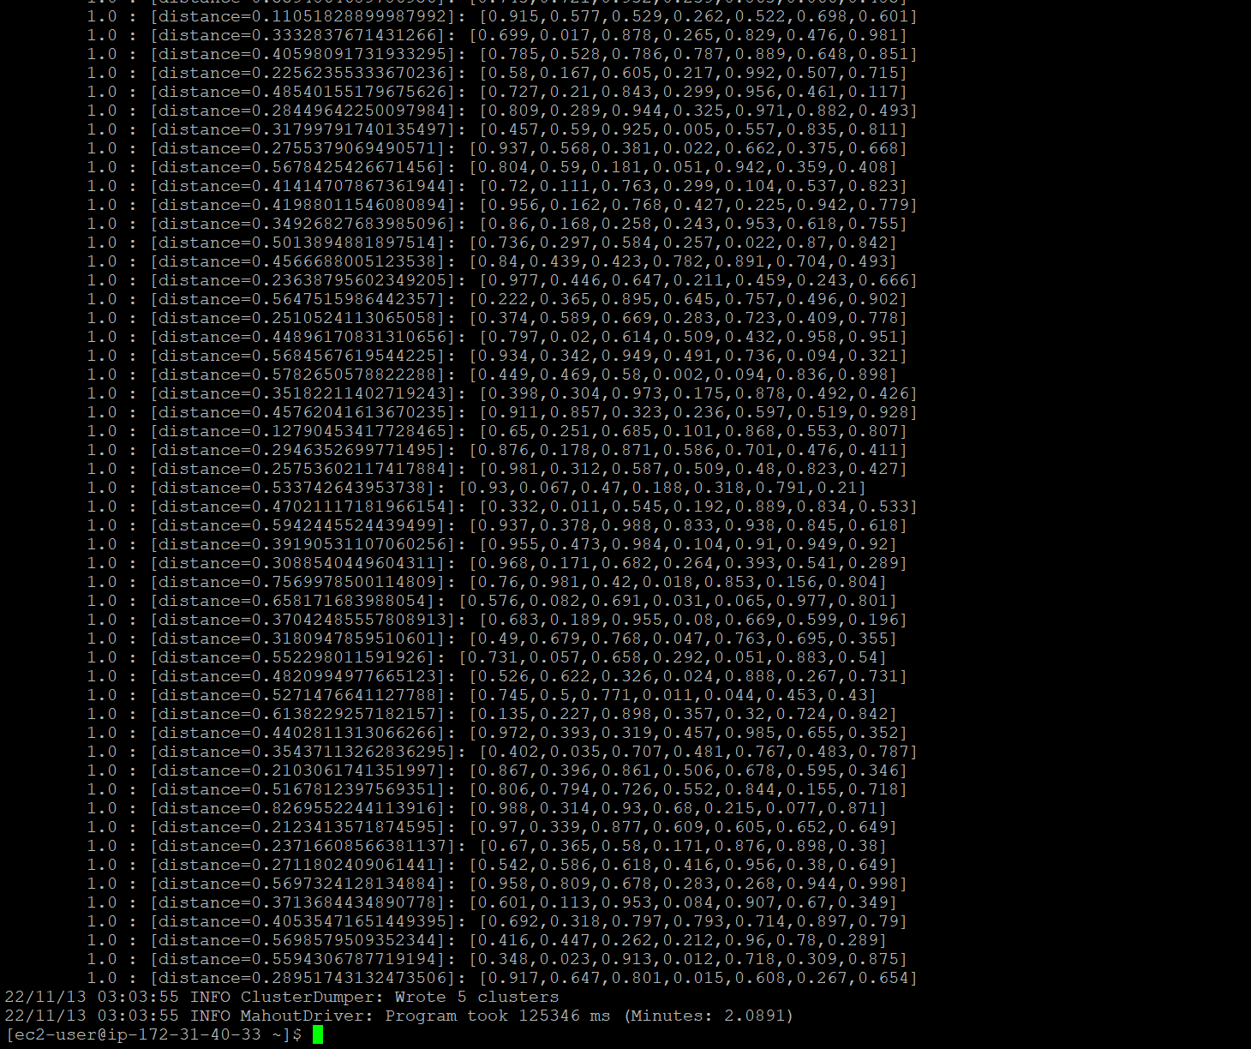

  - Run a recommender on the MoveLens dataset.

(Create a directory for movie lens dataset)
mkdir MovieLens
cd MovieLens
wget http://cdmgcsarprd01.dpu.depaul.edu/CSC555/ml-1m.zip
(Unzip the dataset, this one happens to be compressed with Zip rather than GZip)
unzip ml-1m.zip
cd ..

Take a look at the data file:
more MovieLens/ml-1m/ratings.dat
(you can press q or Ctrl-C to exit, more command shows the first few lines worth of text. Each line contains user ID, movie ID, user rating and the timestamp of the rating, as already discussed in class)
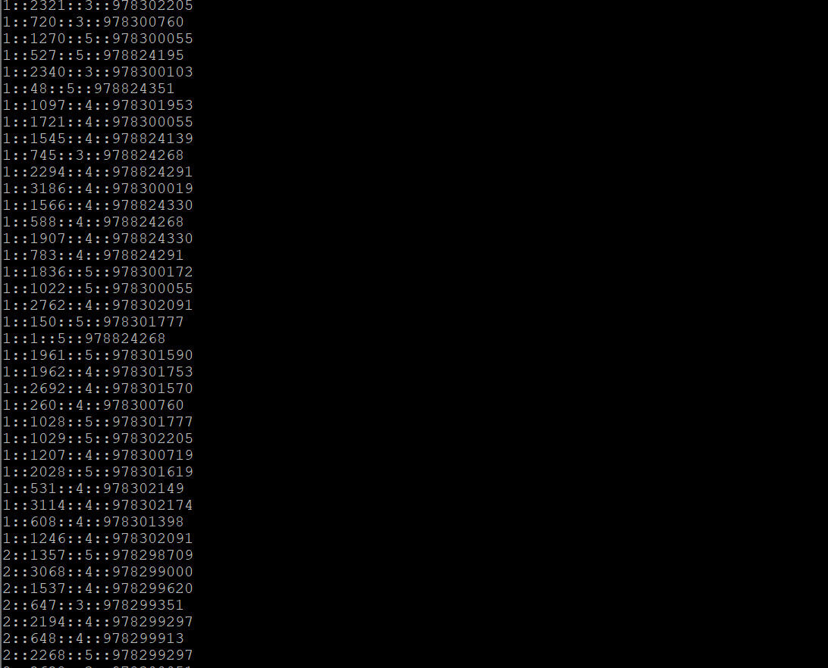

The next step is to use aa Linux command to convert :: separated file into a comma-separated file. First part (cat) will simply output the file. Second part substitutes , for :: and third part of the command extracts just 3 attributes relevant to us (no timestamp)

cat MovieLens/ml-1m/ratings.dat | sed -e s/::/,/g| cut -d, -f1,2,3 > MovieLens/ml-1m/ratings.csv
(NOTE: if you wanted to extract all 4 columns from the original data set, you could run the same command with “1,2,3,4” instead of “1,2,3”).

Create a movielens directory and copy the articles over to HDFS into that directory:
$HADOOP_HOME/bin/hadoop fs -mkdir movielens
$HADOOP_HOME/bin/hadoop fs -put MovieLens/ml-1m/ratings.csv movielens

Split the data set into the 88% training set and 12% evaluation set. In this case we are using Hadoop to perform the split. Naturally, you can change the percentages here to any other value instead of 0.88/0.12.
bin/mahout splitDataset --input movielens/ratings.csv --output ml_dataset --trainingPercentage 0.88 --probePercentage 0.12 --tempDir dataset/tmp

Verify and report the file sizes of the input ratings.csv file and the two sampled files (the two files are in the /user/ec2-user/ml_dataset/trainingSet/ and /user/ec2-user/ml_dataset/probeSet directories on HDFS side). Do the sampled file sizes add up to the original input file size?
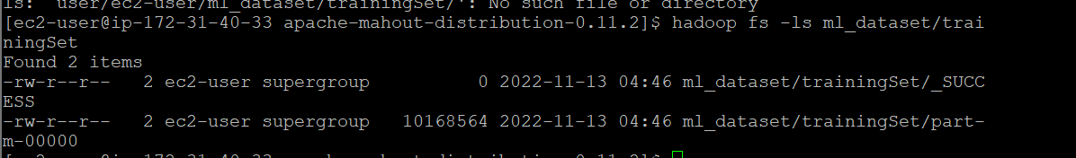

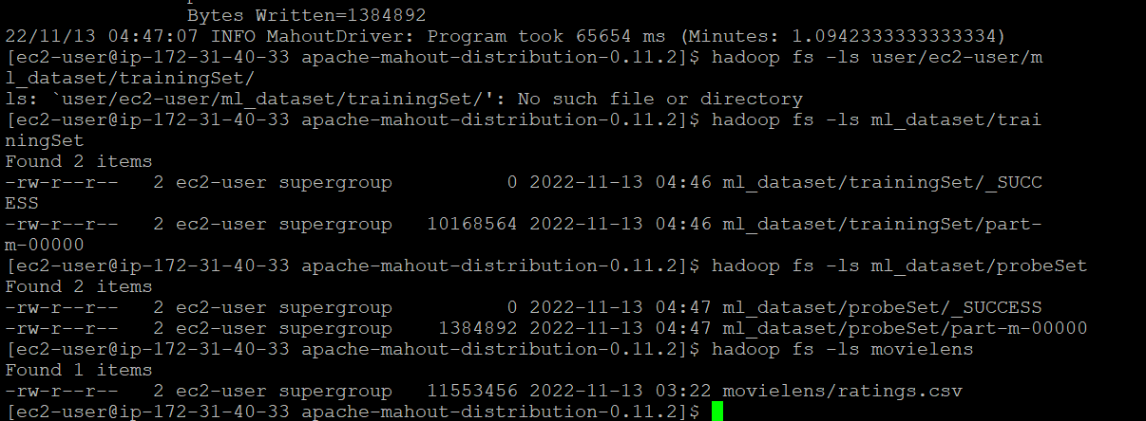

Factorize the rating matrix based on the training set. As always, this is a single line command, be sure to run it as such. The --numfeatures value configures the set of “hidden” variables or the dimension size to use in matrix factorization. --numIterations sets how many passes to perform; we expect a better match with more iterations
time bin/mahout parallelALS --input ml_dataset/trainingSet/ --output als/out --tempDir als/tmp --numFeatures 20 --numIterations 3 --lambda 0.065

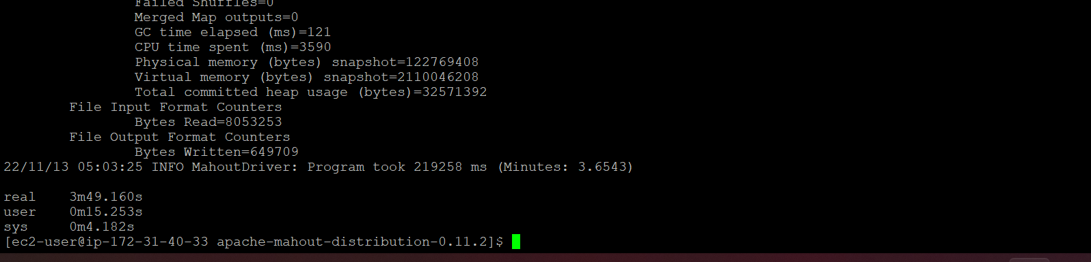

Measure the prediction against the training set:
bin/mahout evaluateFactorization --input ml_dataset/probeSet/ --output als/rmse/ --userFeatures als/out/U/ --itemFeatures als/out/M/ --tempDir als/tmp

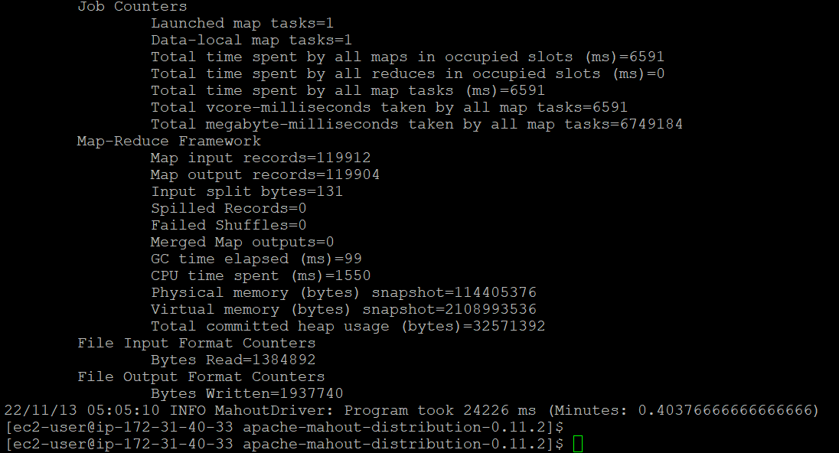

What is the resulting RMSE value? (rmse.txt file is in HDFS /user/ec2-user/als/rmse/)
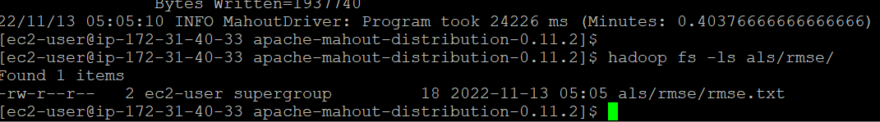

Finally, let’s generate some predictions:
bin/mahout recommendfactorized --input als/out/userRatings/ --output recommendations/ --userFeatures als/out/U/ --itemFeatures als/out/M/ --numRecommendations 6 --maxRating 5

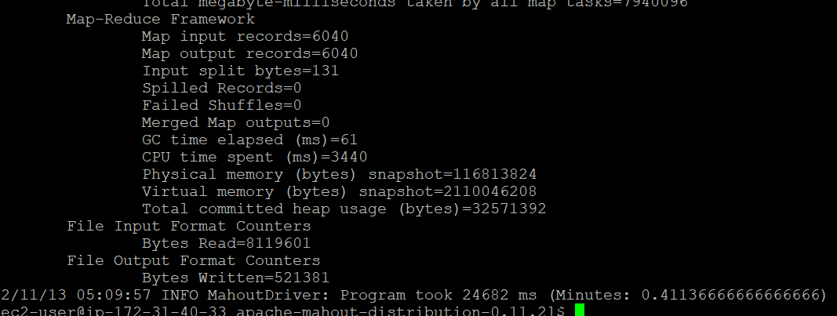

Look at recommendations/part-m-00000 and report the first 10 rows by running the following command. These are top-6 recommendations (note that --numRecommendation setting in the previous command) for each user. Each recommendation consists of movieID and the estimated rating that the user might give to that movie.
$HADOOP_HOME/bin/hadoop fs -cat recommendations/part-m-00000 | head

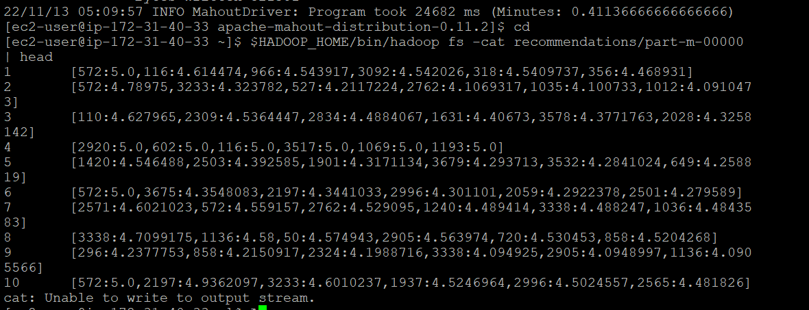

What is the top movie recommendation (movie ID) for users 3 and 5?
movie recommendation for user 3 and 5 are :
- User3 – 110:4
User5 – 1420:4

- OPTIONAL (extra credit)
Set up a stand-alone 3-node Spark cluster. You should use your existing 3-node cluster. You need to add a text file with workers to the conf directory (conf/workers) directory in the spark folder and copy spark directory to each node in the cluster in the same way as you copied Hadoop to each node in the cluster. You do not need to configure Spark beyond adding a workers text file.
Cluster view status can be seen at the browser page at port 8080 (you would need to modify your firewall settings to open port 8080 exactly as you have with port 50700).

You can find a spark binary of the right version here: http://dbgroup.cdm.depaul.edu/Courses/CSC555/spark-2.1.0-bin-hadoop2.6.tar

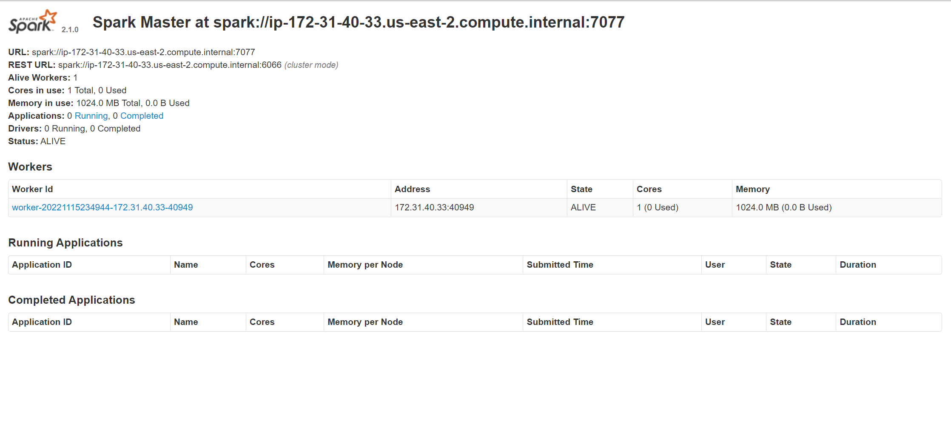

Submit a single document containing your written answers. Be sure that this document contains your name and “CSC 555 Assignment 6” at the top.

